1. what is software? What is software engineering?

🡪 software is group of Interaction and software engineering is process of developing website.

1. Explain types of software?

→ There are five type of software.

• Application software

• System software

• Drive software

• Middleware

• Programing software

1. What is SDLC? Explain each phase of SDLC?

→ SDLC means Software Developer Life Cycle. There are six phase of SDLC.

• First phase → Planing

Ex. → service provider planning with their Client about their website.

• Second phase→ Analyse

Ex.→service provider analyse about client website.

• Third phase→ Designing

Ex.→service provider make design for client website.

• Forth phase→ Implemen Tation

Ex.→service provider do coading for client website.

• Fifth phase→ Testing

Ex.→ service provider testing website.

• Sixth phase→ Maintenance

Ex.→ service provider add any kind of work and remove error.

1. What is DFD? Create a DFD diagram on flipkart?

→ DFD means DATA FLOW DIAGRAM

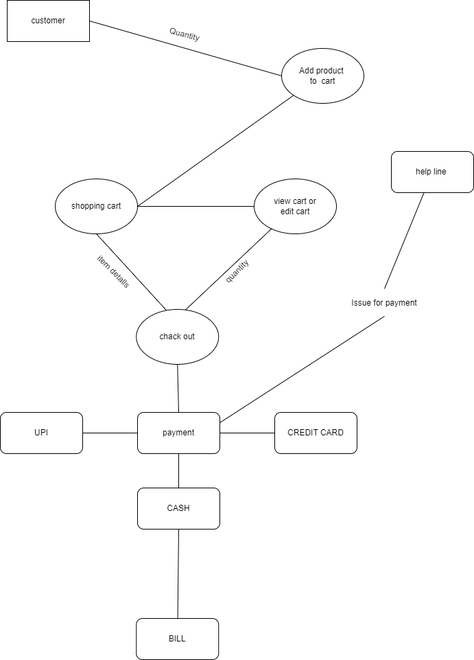

1. What is Flow chart? Create a flowchart to make addition of two number?

→ A Flow chart is a diagram that draft all process.

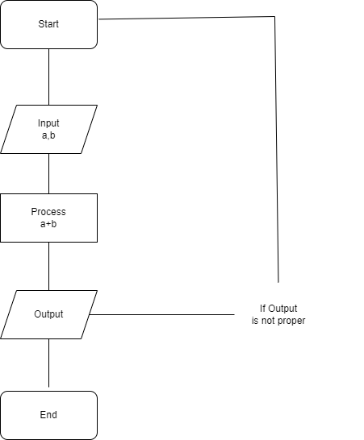

1. What is Use Case Diagram? Create a use case on bill payment on paytm?

→ Use Case Diagram is show which control user can access.

